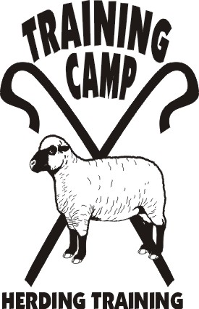

Presents

HERDING 101

Now that you have been bitten by the herding bug do you want to know and understand more about what you are doing and why?

This seminar will give you the opportunity to learn the language, and begin to understand the parts you, the dog, and the livestock play.

April 7, 2007

10 am to 2 pm
$40

This seminar will be held in my home. Limit 10 people. Lunch and seminar materials provided.

Reservations must be made by March 30.

